# Obtaining a Key for the Azure Translator Service

The **TranslationsBuilder** application includes support to generate machine translations with the [Azure Translator service](https://docs.microsoft.com/en-us/azure/cognitive-services/translator/translator-info-overview) that is part of Azure Cognitive Services. This Web API makes it possible to automate enumerating through dataset objects to translate dataset object names from the default language to secondary languages. The diagram below shows the details of executing a Translator service API request to convert a table name from English (en) to Dutch (nl).

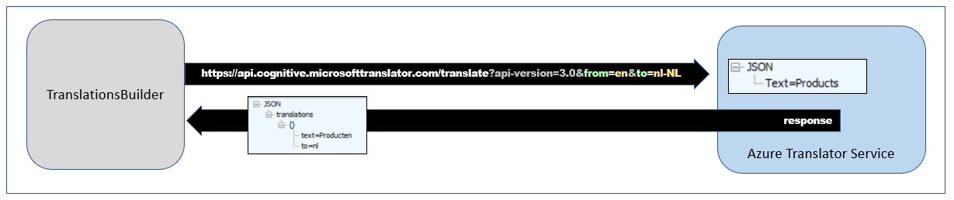

If you'd like to test out the support in **TranslationsBuilder** for generating machine translations, you will require an Azure subscription. An Azure subscription is required because you must create your own instance of the Translator service in Microsoft Azure. Once you have created an instance of the Translator service, you must determine its location and acquire an application key before you can successfully call to it from the **TranslationsBuilder** application.

The Azure Translator service does not support anonymous API calls. Instead, you must acquire an application keys which acts as a security credential because it allows you to execute secure Web API calls to the Translator service. When working with an instance of the Translator service in the Azure portal, you can navigate to the **Keys and Endpoint** page where you can view and acquire an application key.

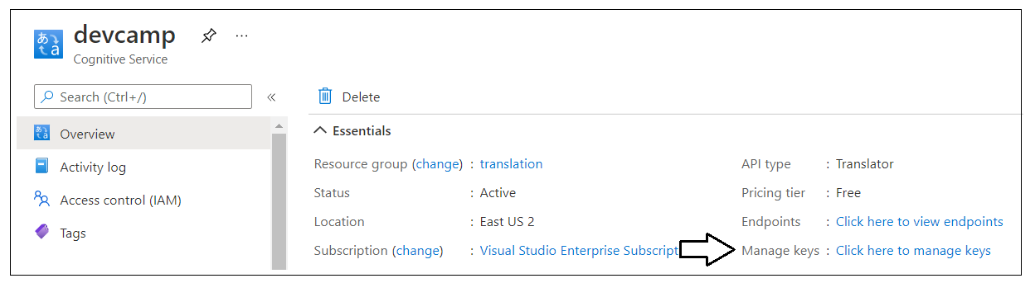

On the **Keys and Endpoint** page, you can copy the application key and then paste it into the **Configuration Options** dialog in **TranslationsBuilder**. You will also need to copy the service **Location** and paste that value into the **Configuration Options** dialog as well.

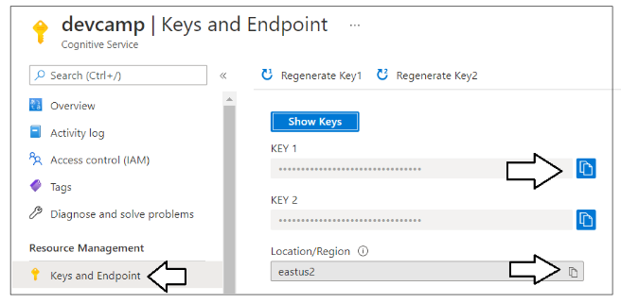

Once you have copy-and-pasted the application key and the location for your Translator service instance, you can save your changes in the **Configuration Options** dialog and begin generating machine translations.

The **TranslationsBuilder** application contains a **Machine Translations** section with a **Generate Translations** button. Note that the **Machine Translations** section will not be visible until you have added an application key and a location for the Azure Translation Service in the **Configuration Options** dialog. Once you have configured **TranslationsBuilder** with an application key and a location for your Translator service instance, you should be able to select a target culture with the language you want and click the **Generate Translations** button to generate machine translation for that language.

